PROCEEDING GUIDELINES

All proceedings must be written in ENGLISH.

Proceeding file must contain TITLE, AUTHORS, AFFILIATIONS, ABSTRACT, KEYWORDS (3 - 6 keywords), INTRODUCTION, MATERIALS AND METHODS, RESULTS, DISCUSSION AND CONCLUSION, and REFERENCES.

Indicate Presenting Author with Underline

Indicate Corresponding Author with Asterisk (*) after the name

FIGURES and TABLES must be INCLUDED in the MANUSCRIPT.

Standard abbreviations can be used throughout. Any special or unusual abbreviations should be spelled out in full at first mention, followed by the abbreviation in parentheses. It is recommended that you use abbreviations minimally in your abstract.

Greek characters (e.g., alpha, beta) in both the title and the text should be spelled out.

Total number of pages should be 4 - 8 pages.

Please be reminded that the research work to be submitted for Proceeding Publication must contain PROTEIN RELATED experiments (e.g. work with only gene cloning may be rejected).

Check carefully for any misspellings and/or typographical errors.

All abstract and proceeding will be peer-reviewed by invited reviewers, the ACCEPTED ABSTRACT or PROCEEDING must also be presented as a POSTER unless it is selected as an oral presentation.

GENERAL FORMATTING:
File format: Microsoft Word (.docx) only
Paper size: A4 ("8.27 x 11.69 in" or "210 x 297 mm")
Page layout: Portrait, single column.
Margins: 1 inch (2.54 cm) at all sides.
Font: Times New Roman
Line spacing: 1.0 (single-spaced; spacing before = 0 pt, after = 0 pt) throughout the text.
Title: Sentence case, 14-point (bold text).
Authors: 12-point (bold text).
Presenting author should be underlined.
Give an asterisk (*) at the corresponding author.
Affiliations: 12-point (regular text).
Headings: e.g., ABSTRACT, INTRODUCTION, RESULTS, etc.
CAPITAL LETTER, 12-point (bold text).
Do not leave a line between the headings and the following text.
Abstract body: 12-point (regular text). Do not exceed 250 words.
Text body: 12-point (regular text).
Paragraph: Start with indentation and Justified to both sides.
Abbreviations: Spelled out, in parenthesis, in the first use in the text.
Unit: SI system.
References: Vancouver style. In addition, please be sure to check the format of in-line reference as follow: indicate references by number (s) in square brackets in the order of their appearance in the text and in line with text (e.g. some text … [1], some text … [2,4], etc.).

Proceeding template

Title (Times New Roman 14, Bold)

Name Surname (underline presenter)¹, Name Surname², …., Name Surname³,* (Times New Roman 12)
1 Affiliation 1 (Times New Roman 12, Italic);
2 Affiliation 2 (Times New Roman 12, Italic);
2 Affiliation 2 (Times New Roman 12, Italic);
* Email of corresponding author (Times New Roman 12, Italic)

ABSTRACT
Non-structural abstracts, Maximum 250 words, No figures and table (Times New Roman 12)

Keywords: 3-6 words (Times New Roman 12)

INTRODUCTION
Times New Roman 12, Single line space, indicates references by number (s) in square brackets in the order of their appearance in the text and in line with text (e.g. some text … [1], some text… [2,4], etc.).

MATERIALS AND METHODS
Subheading 1 (Times New Roman 12, italic)
Description. (Times New Roman 12)

Subheading 2 (Times New Roman 12, italic)
Description. (Times New Roman 12)

Subheading 3 (Times New Roman 12, italic)
Description. (Times New Roman 12)

RESULTS
Subheading 1 (Times New Roman 12, italic)
Description. (Times New Roman 12) When “Figures” and “Tables” were mentioned in the text, they should be bold. As illustrated in Fig. 1A or Table 1

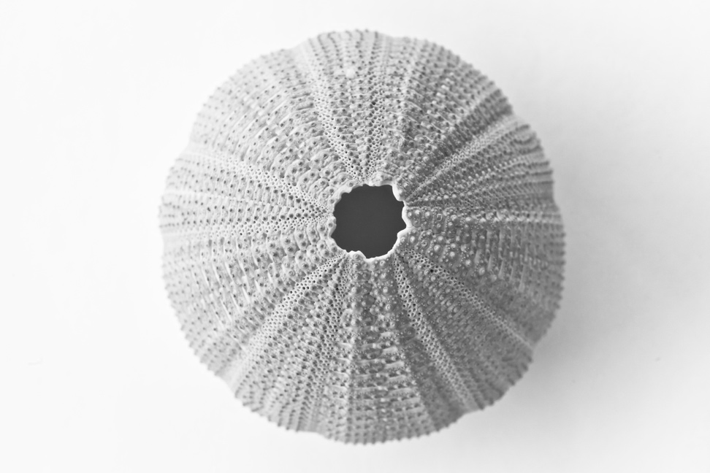
Fig. 1 Figure title (Arial 11, Bold). Figure descriptions (Times New Roman 12)

Subheading 2 (Times New Roman 12, italic)
Description. (Times New Roman 12) When “Figures” and “Tables” were mentioned in the text, they should be bold. As illustrated in Fig. 1A or Table 1

Table 1 Table title (Times New Roman 12, Bold).

DISCUSSION AND CONCLUSION
Discussion, Times New Roman 12, interpretation of the results.
Conclusion is to describe the conductions and/or the significance of the work.

ACKNOWLEDGEMENTS
List the names of individuals or organizations who are not coauthors but have contributed assistance to the research (e.g., funding agencies).

REFERENCES
Times New Roman 12, Vancouver style, please be sure to check the format of in-line reference as follow: indicate references by number(s) in square brackets in the order of their appearance in the text and in line with text (e.g. some text … [1], some text… [2,4], etc.).
e.g.
1. Beizer JL, Timiras ML. Pharmacology and drug management in the elderly. In: Timiras PS, editor. Physiological basis of aging and geriatrics. 2nd ed. Boca Raton: CRC Press; 1994. p. 279-84.
2. Gaffen SL, Liu KD. Overview of interleukin-2 function, production and clinical applications. Cytokine. 2004;28(3):109-23.
3. Hafsi S, Pezzino FM, Candido S, Ligresti G, Spandidos DA, Soua Z, et al. Gene alterations in the PI3K/PTEN/AKT pathway as a mechanism of drug-resistance. Int J Oncol. 2012;40(3):639-44.
4. Meisenberg G, Simmons WH. Principles of medical biochemistry. 2nd ed. Mosby Elsevier; 2006.
5. Mott HR, Driscoll PC, Boyd J, Cooke RM, Weir MP, Campbell ID. Secondary structure of human interleukin 2 from 3D heteronuclear NMR experiments. Biochemistry. 1992;31(33):7741-4.

